

**SOFTWARE REQUIREMENT SPECIFICATION**

**Hotel Management System**

**Group 3 - SE1511-JS**

– Hanoi, January 2022 –

Table of Contents

Record of Changes 4

I. Product Overview 5

1. Product Vision 5

2. Product Context 5

3. Major Features 6

4. User Requirements 6

4.1 Actors List 6

4.2 User Cases 7

5. Assumptions & Dependencies 9

6. Limitations & Exclusion 9

7. Business Rules 9

II. Use Case Specifications 11

1. Manage Booking 11

1.1. Check in 11

1.2. Check out 12

1.3. View Available Room 14

1.4. View Available Service 15

1.5. Search Customer 16

1.6. Payment 17

1.7. View Check-in Information 18

1.8. View Check-out Information 19

1.9. Add new Customer Information 20

1.10. Edit Customer Information 21

1.11. Delete Customer Information 22

1.12. View Customer Information23

2. Manage Room 24

2.1. Add new Room 24

2.2. Delete a Room 25

2.3. View Room List26

3. Manage Service 27

3.1. Add new Service 27

3.2. Delete a Service 28

3.3. View Service List 28

III. Functional Requirements 29

1. System Functional Overview 29

1.1 Screens Flow 29

1.2 Screen Descriptions 31

1.3 Screen Authorization 32

1.4 Non-Screen Functions 32

1.5 Entity Relationship Diagram 33

2. Screen Description 34

2.1 Dashboard 34

2.2 User Login 34

2.3 CRUD Room 36

2.4 CRUD Service 37

2.5 CRUD Staff 38

2.6 View Information of Customer 40

2.7 Check-in information 41

2.8 Check-out information 42

2.9 Payment 43

2.10 User Profile 43

IV. Non-Functional Requirements 44

1. External Interfaces 44

1.1 Software Interfaces 44

1.2 Communication Interfaces 45

2. Quality Attributes 45

2.1 Usability 45

2.2 Safety 45

2.3 Availability 45

2.4 Security 45

2.5 Performance45

# Record of Changes

| **Date** | **A* M, D** | **In charge** | **Change Description** |
| --- | --- | --- | --- |
| 20/01/2022 | A | Nguyen Viet Bao Chau | Major Features |
| 21/01/2022 | A | Trần Ngọc Thắng | Assumptions & Dependencies |
| 22/01/2022 | A | T[rần Hải Long](https://fu.edunext.vn/en/session/activity?sessionid=58290&activityId=466938#) | User Requirements, Limitations and Exclusions |
| 22/01/2022 | A | [Hà Trí Dũng](https://fu.edunext.vn/en/session/activity?sessionid=58290&activityId=466938#) | Product Vision |
| 22/01/2022 | A | Vũ Trí Hiền | Product Context |
| 22/01/2022 | A | Nguyen Viet Bao Chau | Business Rules, Use Case Specifications |
| 23/01/2022 | A | [Hà Trí Dũng](https://fu.edunext.vn/en/session/activity?sessionid=58290&activityId=466938#) | Use Case Specifications |
| 23/01/2022 | A | [Vũ Trí Hiền](https://fu.edunext.vn/en/session/activity?sessionid=58290&activityId=466938#) | Use Case Specifications |
| 23/01/2022 | A | T[rần Hải Long](https://fu.edunext.vn/en/session/activity?sessionid=58290&activityId=466938#) | Use Case Specifications |
| 23/01/2022 | A | [Trần Ngọc Thắng](https://fu.edunext.vn/en/session/activity?sessionid=58290&activityId=466938#) | Use Case Specifications |
| 26/02/2022 | A | Nguyen Viet Bao Chau | System Functional Overview |
| 26/02/2022 | A | Trần Ngọc Thắng | Screen Description |
| 26/02/2022 | A | T[rần Hải Long](https://fu.edunext.vn/en/session/activity?sessionid=58290&activityId=466938#) | Screen Description |
| 26/02/2022 | A | [Hà Trí Dũng](https://fu.edunext.vn/en/session/activity?sessionid=58290&activityId=466938#) | Screen Description |
| 26/02/2022 | A | Vũ Trí Hiền | Screen Description |
| 27/02/2022 | M | Nguyen Viet Bao Chau | System Functional Overview |

*A - Added M - Modified D - Deleted

# I. Product Overview

## 1. Product Vision

Create a hotel management program suitable for users, stakeholders and easy and convenient to manage.

Hotel Management helps staff as well as hotel managers to manage their hotel easily. The manager will be able to manage and track the work schedule of each employee, thereby paying the appropriate salary. As well as being able to see the statistics of the number of guests who have stayed at your hotel by each tourist season and can manage their spending.

In addition, to be able for guests to easily book online to see how many rooms are available and to be able to support the staff for their customers.

The project will solve the problem of traditional hotel management: guests do not know the number of rooms available, so it is easy to consult the price on the web. With a support system, there will be no need to hire more employees to pay wages, the manager's work will be reduced.

## 2. Product Context

The connections between the COS with the external entities are as described in the below diagram

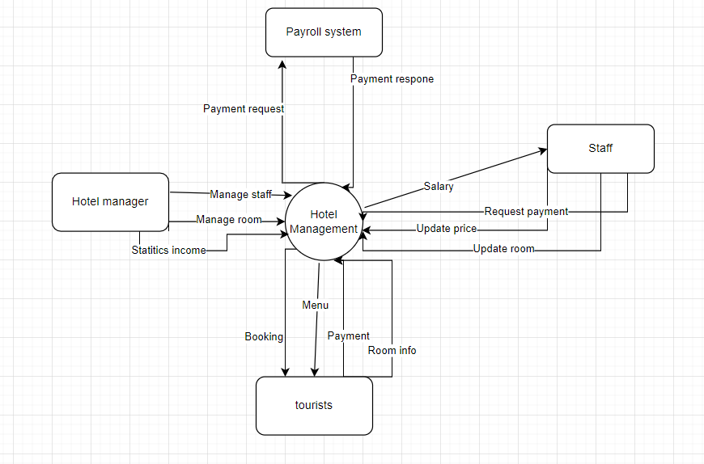

In which:

* Payroll systems can solve payment problems between customers and managers: fee, refund,
* Manager:
* Can manage staff : Salary, timesheet
* Can manage a room: empty room, price of room, edit information of room ( images, number of beds, view, …)
* Tourist: visiting guests can booking online and cancel or search info room
* Staff: Employee support customer, can view empty room and request payment for tourist

## 3. Major Features

FE-1: Check in and Check out.

FE-2: Authenticate user.

FE-3: Create, view, modify, delete and archive customer information.

FE-4: Create, view, modify, delete and archive a room type.

FE-5: Create, view, modify, delete and archive service.

FE-6: View, search available room and service.

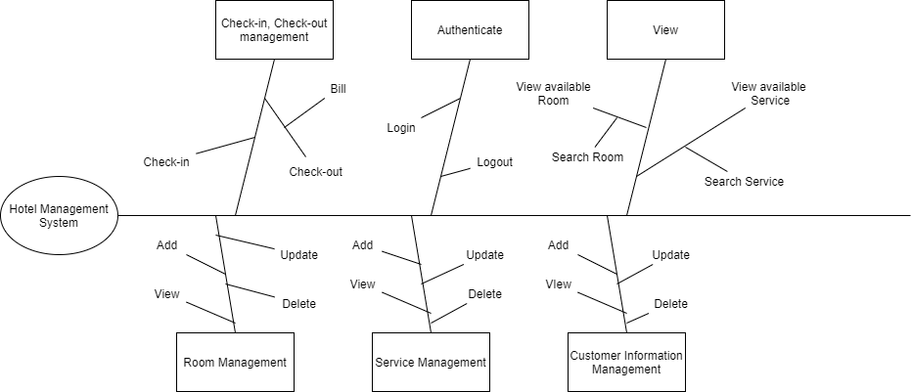

## 4. User Requirements

### 4.1 Actors List

| **#** | **Actor** | **Description** |
| --- | --- | --- |
| 1 | Receptionist | The person who directly interacts with the system, doing almost all the functions of the system. |
| 2 | Room Manager | Manage rooms in the hotel, perform functions with rooms (view, add, edit, delete). |
| 3 | Service Manager | Manage services in the hotel, perform functions with services (view, add, edit, delete) |

### 

### 4.2 User Cases

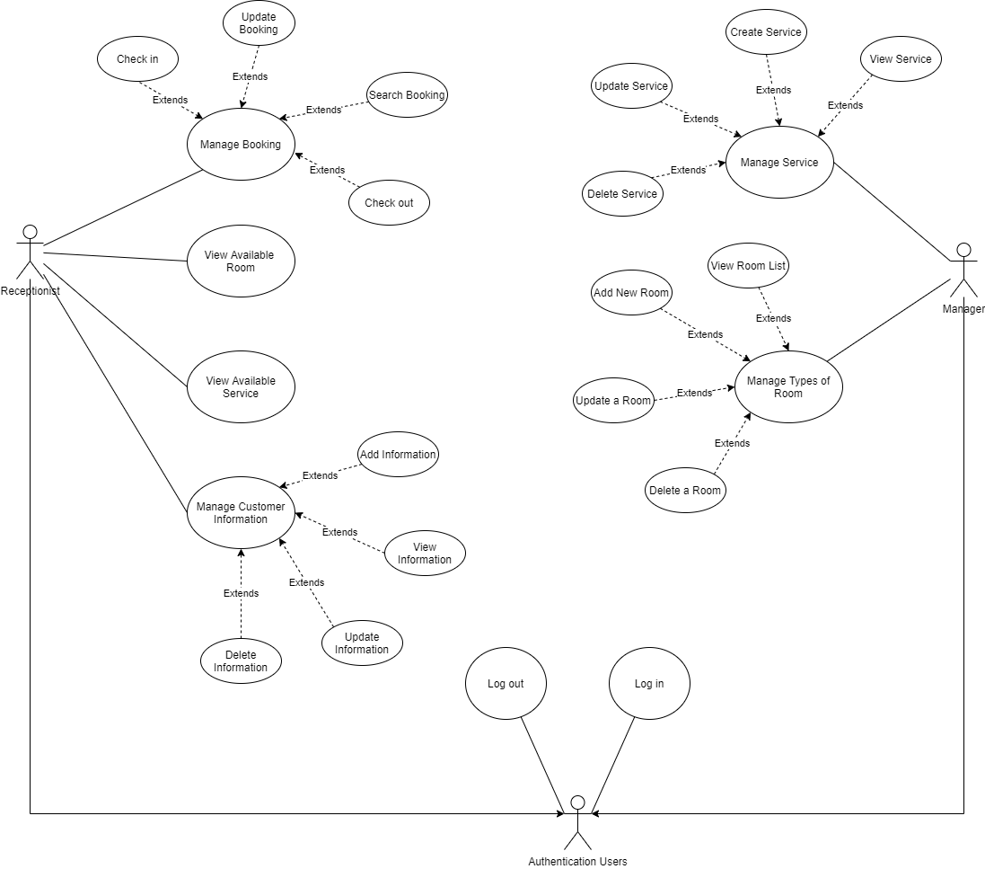

In which

| **ID** | **Feature** | **Use Case** | **Description** |
| --- | --- | --- | --- |
| 01 | Manage Booking | Check in | A receptionist will greet customers directly, depending on whether the customer has booked or not, to arrange suitable rooms and services. Update customer information into the system and confirm registration. The customer will have permission to access their room and use hotel services. |
| 02 | Manage Booking | Check out | A receptionist will check out for customers when the time comes. Receptionist will calculate based on customer check-in information and the time customer check-out for the customer to pay the bill. |
| 03 | Manage Booking | Make bill | Receptionist will make the total of the price when the customer checks-out. |
| 04 | Manage Booking | View Available Room | Receptionist will check the hotel's availability room list. If that room is available, the staff will arrange guests in that room and match with the customer's request. |
| 05 | Manage Booking | View Available Service | Receptionist will check the hotel's availability service list. If that service is available, the staff will arrange guests in that service and match with the customer's request. |
| 06 | Manage Booking | View Check-in information | Receptionist will check the customer’s check-in. |
| 07 | Manage Booking | Search Check-in information | Receptionist will search the information of the customer's check-in. |
| 08 | Manage Booking | Edit Check-in information | Receptionist will update the status of the information's check in. |
| 09 | Manage Booking | View Check-out information | Receptionist will check the customer’s check-out. |
| 10 | Manage Booking | Search Check-out information | Receptionist will search the information of the customer's check-out. |
| 11 | Manage Booking | Edit Check-out information | Receptionist will update the status of the customer's check out. |
| 12 | Manage Booking | Add New Customer information | Receptionist will add new customers when they book in the Hotel. |
| 13 | Manage Booking | View Customer information | Receptionist will view the list of customer’s information. |
| 14 | Manage Booking | Edit Customer information | Receptionist will update the information of the customer. |
| 15 | Manage Booking | Delete Customer information | Receptionist will delete the information of the customer when they check out |
| 16 | Manage Room | Add New Room | The Hotel Management System may change the service for a specific date in the future, modify it to remove or change services, remove or change the price and save the modified service. |
| 17 | Manage Room | Delete a Room | The Hotel Management System may change the room for a specific date in the future, modify it to remove or change rooms, remove or change the price and save the modified room. |
| 18 | Manage Room | Edit a Room | The Hotel Management System may edit the status of the room. |
| 19 | Manage Room | View Room List | The Hotel Management System may view the list of all the rooms. |
| 20 | Manage Service | Add New Service | The Hotel Management System may change the service for a specific date in the future, modify it to add or change services, create or change a special service, or change the price and save the modified service. |
| 21 | Manage Service | Delete a Service | The Hotel Management System may change the service for a specific date in the future, modify it to remove or change services, remove or change the price and save the modified service. |
| 22 | Manage Service | Edit a Service | The Hotel Management System may edit the status of the service. |
| 23 | Manage Service | View Service List | The Hotel Management System may view the list of all the services. |

## 

## 5. Assumptions & Dependencies

AS-1: Using Windows OS with .NET 5 framework.

AS-2: Advertising notification will show in smart ways.

DE-1: Only payment by visa mastercard.

## 6. Limitations & Exclusions

LI-1: Some of the dishes available on the Hotel's Food and Beverage menu will not be suitable for delivery, so customers are advised to choose products that are still in stock.

LI-2: The system shall only be used for <<Hotel Name>> at <<Hotel Address>>

## 7. Business Rules

| **ID** | **Category** | **Rule Definition** |
| --- | --- | --- |
| BR-01 | Constraints | Customers will pay 30%, 50% extra more if they check-out late before 15:00, 18:00, and 100% after 18:00. |
| BR-02 | Constraints | Check-in time is 12:00, any earlier check-in will pay an extra 30% cost. |
| BR-03 | Facts | A room in HMS display with a green label (available) or white (taken). |
| BR-04 | Facts | If a room is not available, the receptionist can’t assign customers to that room. |
| BR-05 | Facts | A service in HMS display with a green label (available) or white(not available). |
| BR-06 | Constraints | If a service in HMS is confirmed to be used by the user, they will not be able to cancel the order after 3 minutes. |
| BR-07 | Constraints | The customer must have a valid id number to check in or check out. |
| BR-08 | Constraints | Customer information will be saved for faster check-in if an old customer comes back. |
| BR-09 | Constraints | Customers will pay 50% of the room and service cost when checking in and the rest 50% when checking out. |
| BR-10 | Constraints | Any damage to the room will pay extra money based on the room cost. |
| BR-11 | Constraints | If a customer wants to book a room by month, the room cost will be 40% less. |
| BR-12 | Constraints | If a customer has a reservation they have to pay a 30% deposit and the room assigned changes to “taken” status, but if they don’t come when the check-in time comes. The room will be changed back to “available” status and won’t return the money back. |
| BR-13 | Constraints | Customer check-in time until check-out (room rental) must be at least one day. |
| BR-14 | Constraints | The system will have statistical reports based on hotel income filtered by week, month, and year. |
| BR-15 | Constraints | System payment will only accept Visa, Master cards. |
| BR-16 | Constraints | If the customer goes in by the group, the total room cost is calculated by room and the service price is calculated by a person. |
| BR-17 | Constraints | The maximum bed per room is two. |
| BR-18 | Constraints | The maximum person per room is four. |

# II. Use Case Specifications

## 1. Manage Booking

### 1.1. Check in

| ID and Name: | **UC-01 Check-in** | | |
| --- | --- | --- | --- |
| Created By: | Nguyễn Viết Bảo Châu | Date Created: | 22/01/2022 |
| Primary Actor: | Receptionist | Secondary Actors: | N/A |
| Description: | A receptionist will greet customers directly, depending on whether the customer has booked or not, to arrange suitable rooms and services. Update customer information into the system and confirm registration The customer will have permission to access their room and use hotel services. | | |
| Trigger: | Receptionist make a check in for customer in the hotel | | |
| Preconditions: | PRE-1. Receptionist logged into HMS | | |
| Postconditions: | POST-1. Customer and check-ins information will be stored system  POST-2. Remaining available rooms and services in the system are updated. | | |
| Normal Flow: | **1.0 Check-in for single guest**  1. The receptionist pressed the “new booking” button.  2. HMS displays a form to enter the customer’s information or select old customer’s information that exists in the HMS.  3. HMS will check and provide available rooms on the check-in date, also filter the list of room types, bed quantity, people quantity to select.  4. Receptionist selects a room that meets the customer's request.  5. HMS will check and provide available services to select  6. The receptionist can select multiple services as customer requests.  7. HMS will display a form to enter customers’ payment information.  8. The receptionist enters the customer’s payment information and HMS will calculate the cost to pay.  9. HMS confirms the acceptance of the check-in. | | |
| Alternative Flows: | **1.1 Check in for Group**  1. One person will act as a check-in representative.  2. Return to step-1 of Normal flow.  3. As the step-4 of Normal flow, Receptionists can select multiple rooms for customers. | | |
| Exceptions: | **1.0.E1 The customer checks-in too early.**  1. Receptionist will tell the customer that it’s too early to check-in for today.  2a. If a customer wants to check-in early, then HMS will not allow the use case.  2b. Else if a customer comes back later, then HMS restarts use case.  **1.0.E2 Information incorrect**  1. This occurs if the customer’s information and registration are incorrect and need to be modified. The actor will correct any information that is deemed incorrect and the use case will continue.  2a. The customer will correct any changes that are deemed incorrect and the use case will continue at steps 5.  2b. Else if Customer cant correct information, terminate the use case. | | |
| Priority: | High | | |
| Frequency of Use: | Approximately 200 users, average of three usage per day. Peak usage load for this use case is between 7:00 A.M. and 9:00 A.M. or between 7:00 P.M and 9:00 P.M local time. | | |
| Business Rules: | BR-2 | | |
| Other Information: | 1. The customer shall be able to view all services and options  2. After gaining permission, the customer can make any change about their room and services if it is acceptable.  3. Only Receptionist can check-in | | |
| Assumptions: |  | | |

### 1.2. Check-out

### 

| ID and Name: | **UC-02 Check-out** | | |
| --- | --- | --- | --- |
| Created By: | Nguyễn Viết Bảo Châu | Date Created: | 22/01/2022 |
| Primary Actor: | Receptionist | Secondary Actors: | N/A |
| Description: | A receptionist will check out for customers when the time comes. Receptionist will calculate based on customer check-in information and the time customer check-out for the customer to pay the bill. | | |
| Trigger: | A Customer want to check-out when the time come | | |
| Preconditions: | PRE-1. Receptionist logged into HMS. | | |
| Postconditions: | POST-1. Customer and check-out information will be stored in the system.  POST-2. Remaining available rooms and services in the system are updated. | | |
| Normal Flow: | **2.0 Check-out for single guest**  1. In the check out tab, HMS will display a list of customer bookings that check out date is coming and a search bar by name.  2. Receptionist will select customer booking information.  3. HMS displays a form to enter payment information to make payment.  4. Receptionist enter customer’s payment information and HMS will calculate the cost to pay  5. HMS confirms acceptance of the check-out.. | | |
| Alternative Flows: | N/A | | |
| Exceptions: | **2.0.E1 Unable to Process Transaction.**  1. Receptionist will tell the customer that the payment has been cancelled for some reason.  2a. Customers will have to use other methods or information for payment to continue the use case  2b. Else if a customer can’t finish the payment, then HMS terminates the use case.  **2.0.E2 Charges incorrect**  1. This occurs if there exists a charge or charges on the customer’s bill that are incorrect and need to be modified. The actor will correct any charges that are deemed incorrect and the use case will continue.  2a. The customer will correct any charges that are deemed incorrect and the use case will continue at steps 5.  2b. Else if Customer cant correct information, terminate the use case. | | |
| Priority: | High | | |
| Frequency of Use: | Approximately 150 users, average of three usage per day. Peak usage load for this use case is between 2:00 A.M. and 4:00 P.M. | | |
| Business Rules: | BR-1 | | |
| Other Information: | 1. Only Receptionist can check-out | | |
| Assumptions: |  | | |

### 

### 1.3. View Available Room

### 

| ID and Name: | **UC-04 View Available Room** | | |
| --- | --- | --- | --- |
| Created By: | Nguyễn Viết Bảo Châu | Date Created: | 22/01/2022 |
| Primary Actor: | Receptionist | Secondary Actors: | N/A |
| Description: | Receptionist will check the hotel's availability room list. If that room is available, the staff will arrange guests in that room and match with the customer's request. | | |
| Trigger: | Receptionists check the availability of the room to arrange guests in the room according to the guest's request when check-ins. | | |
| Preconditions: | PRE-1. Receptionist logged into HMS. | | |
| Postconditions: | POST-2. Staff will save the arranged room to customer information, if any. | | |
| Normal Flow: | **4.0 View available room for check in**  1. Receptionist will request HMS to see the available room list in the hotel.  2. HMS will display the available room and filter option.  3. Receptionist selects rooms that match with the customer request.  4. HMS will send the room information to check-ins.  5. After confirming with the guest, HMS saves the room information in the customer check-ins. | | |
| Alternative Flows: | None | | |
| Exceptions: | **4.0.E1 Empty list.**  1. HMS notifies that there is no room available at the check in date.  2.a. If the user cancels the registration process, HMS will terminate the use case.  2.b. Conversely, if a customer comes back when there is available room another date, HMS will restart the use case. | | |
| Priority: | High | | |
| Frequency of Use: | Approximately 200 users, average of five usage per day. Peak usage load for this use case is between 7:00 A.M. and 4:00 P.M. | | |
| Business Rules: | BR-3, BR-4 | | |
| Other Information: | N/A | | |
| Assumptions: |  | | |

### 1.4. View Available Service

### 

| ID and Name: | **UC-05 View Available Service** | | |
| --- | --- | --- | --- |
| Created By: | Nguyễn Viết Bảo Châu | Date Created: | 22/01/2022 |
| Primary Actor: | Receptionist | Secondary Actors: | N/A |
| Description: | When check-in the Receptionist wants to search for a specific room type suit for the customer request | | |
| Trigger: | Receptionist want to search for a room type | | |
| Preconditions: | PRE-1. Hotel staff logged into HMS. | | |
| Postconditions: | N/A | | |
| Normal Flow: | **5.0 View available service for check in**  1. Receptionist will request HMS to see the available service list in the hotel.  2. HMS will display the available services list to select.  3. Receptionists can select multiple services that match with the customer request. | | |
| Alternative Flows: | None | | |
| Exceptions: | **5.0.E1 Empty list**  1. HMS notifies that there is no available service ịn the hotel.  2.a. If the user cancels the registration. HMS will terminate the use case.  2.b. Conversely, if a customer wants to skip. HMS will continue the use case. | | |
| Priority: | High | | |
| Frequency of Use: | Approximately 10 times per week by Searching Room | | |
| Business Rules: | N/A | | |
| Other Information: | N/A | | |
| Assumptions: |  | | |

### 1.5. Search Customer

### 

| ID and Name: | **UC-8 Search Customer** | | |
| --- | --- | --- | --- |
| Created By: | Nguyễn Viết Bảo Châu | Date Created: | 22/01/2022 |
| Primary Actor: | Receptionist | Secondary Actors: | N/A |
| Description: | Receptionists log into the system and input the name/identity card of customers to check if they have a reservation or not .The system saves the information of customers so staff can take customer’s information. | | |
| Trigger: | Receptionist input the name or identity card of a customer | | |
| Preconditions: | PRE-1. Receptionist logged into HMS. | | |
| Postconditions: | POST-1: Request is stored in HMS  POST-2: Request is sent to Room manager or to a customer. | | |
| Normal Flow: | **8.0 Search Customer**  1. In the customer tab, the HMS will show the customer list and search bar to enter ID or Customer name.  2. The Receptionist will choose to search by ID or Name, enter information and click search.  3. The HMS will show the customer list that ID or name contains the text on the search bar. | | |
| Alternative Flows: | N/A | | |
| Exceptions: | Can’t find customer information in the system because there is no customer information like requested information saved in the system befored. | | |
| Priority: | High | | |
| Frequency of Use: | Approximately 10 times per week by Searching Room | | |
| Business Rules: | N/A | | |
| Other Information: | Only the receptionist can search for customers. | | |
| Assumptions: |  | | |

### 1.6. Payment

| ID and Name: | **UC-1.6 Make bill** | | |
| --- | --- | --- | --- |
| Created By: | Vũ Trí Hiền | Date Created: | 20/01/2022 |
| Primary Actor: | Room Manager | Secondary Actors: | N/A |
| Description: | After tourist booking room, Hotel manager or Staff make bill to tourist pay the fee and the bank will authenticate the customer account | | |
| Trigger: | The tourist tries to pay for a booking room. | | |
| Preconditions: | The manager shall know the infor room . | | |
| Postconditions: | The payment of customer’s orders is received | | |
| Normal Flow: | **1.6 Make bill**  1. The tourist should booking room in hotel  2. HMS will display a form to enter new room information with bed quantity, room number, people quantity, name, …  3. Manager created the bill .  4. The bank authenticates the payment made by the tourist  5. The tourist pay to fee | | |
| Alternative Flows: | 1. The user booking room in list in HMS  2. The user pays for booking fee | | |
| Exceptions: | If the tourist does not have sufficient funds in his bank account | | |
| Priority: | High | | |
| Frequency of Use: | Approximately 200 users, average of six usage per day. Peak usage load for this use case is between 7:00 A.M. and 4:00 P.M. | | |
| Business Rules: | BR-09 | | |
| Other Information: | N/A | | |
| Assumptions: |  | | |

### 

### 1.7. View check-in information

| ID and Name: | **UC-7 View Check-in Information** | | |
| --- | --- | --- | --- |
| Created By: | Vũ Trí Hiền | Date Created: | 23/01/2022 |
| Primary Actor: | Receptionist | Secondary Actors: | N/A |
| Description: | Receptionist will check the customer’s check-in | | |
| Trigger: | Receptionist wants to check for a specific customer check-in information | | |
| Preconditions: | PRE-1. Hotel staff logged into HMS. | | |
| Postconditions: | N/A | | |
| Normal Flow: | **9.0 View check-in information**  1. Receptionist will request HMS to see check-in information of a specific customer.  2. HMS will display check-in information for user. | | |
| Alternative Flows: | None | | |
| Exceptions: | None | | |
| Priority: | High | | |
| Frequency of Use: | Approximately 10 times per week by Searching Room | | |
| Business Rules: | N/A | | |
| Other Information: | N/A | | |
| Assumptions: |  | | |

### 1.8. View check-out information

| ID and Name: | **UC-09 View Check-out Information** | | |
| --- | --- | --- | --- |
| Created By: | Trần Ngọc Thắng | Date Created: | 23/01/2022 |
| Primary Actor: | Receptionist | Secondary Actors: | N/A |
| Description: | Receptionist will check the customer’s check-out | | |
| Trigger: | Receptionist wants to check for a specific customer check-out information | | |
| Preconditions: | PRE-1. Hotel staff logged into HMS. | | |
| Postconditions: | N/A | | |
| Normal Flow: | **9.0 View check-out information**  1. Receptionist will request HMS to see check-out information of a specific customer.  2. HMS will display check-out information. | | |
| Alternative Flows: | None | | |
| Exceptions: | None | | |
| Priority: | High | | |
| Frequency of Use: | Approximately 10 times per week by Searching Room | | |
| Business Rules: | N/A | | |
| Other Information: | N/A | | |
| Assumptions: |  | | |

### 1.9. Add new Customer Information

| ID and Name: | **UC-12 Add new Customer Information** | | |
| --- | --- | --- | --- |
| Created By: | Trần Hải Long | Date Created: | 22/01/2022 |
| Primary Actor: | Reception | Secondary Actors: | N/A |
| Description: | When Customers come to check-in the hotel, the Receptionist will directly enter customer information into the Hotel Management System.. | | |
| Trigger: | Customer wants to book a room. | | |
| Preconditions: | PRE-1: Receptionist logged into HMS. | | |
| Postconditions: | N/A | | |
| Normal Flow: | **Add new Customer Information**  1. Receptionist will click the “New Booking” button.  2. HMS will display a form to enter new customer information with Customer ID, name, room name, booking date, service type, …  3. Receptionist will confirm customer information.  4. HMS will check if the Customer ID is duplicate, if not save data in the HMS. | | |
| Alternative Flows: | None | | |
| Exceptions: | Duplicate customer.  1. HMS notifies the Receptionist that Customer ID already exists.  2. If the user cancels the add process, HMS will terminate the use case | | |
| Priority: | High | | |
| Frequency of Use: | Approximately 200 users, average of six usage per day. Peak usage load for this use case is between 7:00 A.M. and 4:00 P.M. | | |
| Business Rules: | N/A | | |
| Other Information: | N/A | | |
| Assumptions: |  | | |

### 

### 1.10. Edit customer information

| ID and Name: | **UC-14 Edit Customer Information** | | |
| --- | --- | --- | --- |
| Created By: | Trần Hải Long | Date Created: | 22/01/2022 |
| Primary Actor: | Reception | Secondary Actors: | N/A |
| Description: | When a customer or the receptionist wants to update the customer’s ìnormation. | | |
| Trigger: | Receptionist wants to update customer information. | | |
| Preconditions: | PRE-1: Receptionist logged into HMS. | | |
| Postconditions: | POST-1:Customer information is stored in HMS | | |
| Normal Flow: | **Edit Customer Information**  1. Receptionist will click the “Edit Customer Information” button.  2. HMS will ask for the customer’s ID or Name  3. HMS will display a form to enter new customer information with Customer name, room name, booking date, service type, …  4. Receptionist will confirm customer information. | | |
| Alternative Flows: | None | | |
| Exceptions: | Can’t find Customer Information in the HMS because there is no customer information similar to the request, which is stored on the system. | | |
| Priority: | High | | |
| Frequency of Use: | Approximately 200 users, average of six usage per day. Peak usage load for this use case is between 7:00 A.M. and 4:00 P.M. | | |
| Business Rules: | N/A | | |
| Other Information: | N/A | | |
| Assumptions: |  | | |

### 

### 1.11. Delete customer information

| ID and Name: | **UC-15 Delete Customer Information** | | |
| --- | --- | --- | --- |
| Created By: | Trần Hải Long | Date Created: | 22/01/2022 |
| Primary Actor: | Reception | Secondary Actors: | N/A |
| Description: | Receptionist will delete customer information after customer check-out | | |
| Trigger: | Receptionist wants to delete customer information after check-out | | |
| Preconditions: | PRE-1: Receptionist logged into HMS. | | |
| Postconditions: | POST-1:Customer check-out the Hotel | | |
| Normal Flow: | **Delete customer information**  1. Receptionist will click the “Delete Customer Information” button.  2. HMS will ask for the customer’s ID or Name  3. HMS will confirm with receptionist (Delete Or Not)  4. Receptionist clicks delete and customer information is deleted | | |
| Alternative Flows: | None | | |
| Exceptions: | Can’t find Customer Information in the HMS because there is no customer information similar to the request, which is stored on the system. | | |
| Priority: | High | | |
| Frequency of Use: | Approximately 200 users, average of six usage per day. Peak usage load for this use case is between 7:00 A.M. and 4:00 P.M. | | |
| Business Rules: | N/A | | |
| Other Information: | N/A | | |
| Assumptions: |  | | |

### 1.12. View Customer information

| ID and Name: | **UC-13 View Customer Information** | | |
| --- | --- | --- | --- |
| Created By: | Trần Ngọc Thắng | Date Created: | 23/01/2022 |
| Primary Actor: | Receptionist | Secondary Actors: | N/A |
| Description: | Receptionist will view the list of customer’s information. | | |
| Trigger: | Receptionist wants to check for a specific customer’s information | | |
| Preconditions: | PRE-1. Hotel staff logged into HMS. | | |
| Postconditions: | N/A | | |
| Normal Flow: | **13.0 View Customer information**  1. Receptionist will request HMS to see check-out information of a specific customer.  2. HMS will display Customer information. | | |
| Alternative Flows: | None | | |
| Exceptions: | **13.0.E1 Customer doesn’t exist**  Can’t find customer information in the system because there is no customer information like requested information saved in the system before. | | |
| Priority: | High | | |
| Frequency of Use: | Approximately 10 times per week by Searching Room | | |
| Business Rules: | N/A | | |
| Other Information: | N/A | | |
| Assumptions: |  | | |

## 2. Manage Room

### 2.1. Add new Room

| ID and Name: | **UC-16 Add new Room** | | |
| --- | --- | --- | --- |
| Created By: | Nguyễn Viết Bảo Châu | Date Created: | 22/01/2022 |
| Primary Actor: | Room Manager | Secondary Actors: | N/A |
| Description: | The Hotel Management System may change the room for a specific date in the future, modify it to add or change services, create or change a special service, or change the price and save the modified service. | | |
| Trigger: | Manager wants to create a new Room. | | |
| Preconditions: | PRE-1: Manager logged into HMS. | | |
| Postconditions: | N/A | | |
| Normal Flow: | **16.0 Add new room**  1. In the room tab, the manager clicks on the “Add new room” tab.  2. HMS will display a form to enter new room information with bed quantity, room number, people quantity, name, …  3. Manager enters new room information.  4. HMS will check if the room number is duplicate, if not save data in the HMS. | | |
| Alternative Flows: | None | | |
| Exceptions: | 16.0.E1 Duplicate room number.  1. HMS notifies the Manager that the room number already exists.  2.a. If the user cancels the add process, HMS will terminate the use case.  2.b. Conversely, if a customer changes the room number, HMS will continue the use case. | | |
| Priority: | High | | |
| Frequency of Use: | Approximately 200 users, average of six usage per day. Peak usage load for this use case is between 7:00 A.M. and 4:00 P.M. | | |
| Business Rules: | BR-5 | | |
| Other Information: | N/A | | |
| Assumptions: |  | | |

### 2.2. Delete a Room

### 

| ID and Name: | **UC-17 Delete a Room** | | |
| --- | --- | --- | --- |
| Created By: | Nguyễn Viết Bảo Châu | Date Created: | 22/01/2022 |
| Primary Actor: | Room Manager | Secondary Actors: | N/A |
| Description: | The Hotel Management Systemmay change the room for a specific date in the future, modify it to remove or change rooms, remove or change the price and save the modified room. | | |
| Trigger: | Manager wants to delete a Room. | | |
| Normal Flow: | 1. In the room tab, the manager will select the room in the data grid and press the “Delete room” button.  2. The HMS will check if the room is used by any customer now. If not, delete data in the system. | | |
| Alternative Flows: | None | | |
| Exceptions: | No rooms are duplicated; show error messages and allow the Manager to enter a new room. | | |
| Priority: | High | | |
| Business Rules: | N/A | | |
| Other Information: | Only manager can modify service | | |
| Assumptions: |  | | |

### 2.3. View Room List

| ID and Name: | **UC-19 View Room List** | | |
| --- | --- | --- | --- |
| Created By: | Hà Trí Dũng | Date Created: | 23/01/2022 |
| Primary Actor: | Room Manager | Secondary Actors: | N/A |
| Description: | The Hotel Management System may view the list of all the rooms. | | |
| Trigger: | Receptionist want to check room list | | |
| Preconditions: | PRE-1. Room Manager logged into HMS. | | |
| Postconditions: | N/A | | |
| Normal Flow: | **19.View Room list**  1. Receptionist will request HMS to see the room list in the hotel.  2. HMS will display the rooms list.  3. Room manager can select out of date rooms to maintain. | | |
| Alternative Flows: | None | | |
| Exceptions: | There is no out of date room. | | |
| Priority: | High | | |
| Frequency of Use: | Approximately 2 times per day by Room Manager | | |
| Business Rules: | N/A | | |
| Other Information: | N/A | | |
| Assumptions: |  | | |

## 3. Manage Service

### 3.1. Add new Service

| ID and Name: | **UC-20 Add new Service** | | |
| --- | --- | --- | --- |
| Created By: | Nguyễn Viết Bảo Châu | Date Created: | 22/01/2022 |
| Primary Actor: | Room Manager | Secondary Actors: | N/A |
| Description: | The Hotel Management System may change the service for a specific date in the future, modify it to add or change services, create or change a special service, or change the price and save the modified service. | | |
| Normal Flow: | 1. In the service tab, the manager will click at the “Add new service” button.  2. The HMS will display a form to enter new service information.  3. Manager enters new service information.  4. HMS will check if service is duplicate. If not, save data to the system. | | |
| Alternative Flows: | None | | |
| Exceptions: | No services are duplicated; show error messages and allow the Manager to enter a new service.  1. HMS notifies the Manager that the room number already exists.  2.a. If the user cancels the add process, HMS will terminate the use case.  2.b. Conversely, if a customer changes the room number, HMS will continue the use case. | | |
| Priority: | High | | |
| Business Rules: | N/A | | |
| Other Information: | Only managers can modify service. | | |
| Assumptions: |  | | |

### 

### 3.2. Delete a Service

| ID and Name: | **UC-21 Delete a Service** | | |
| --- | --- | --- | --- |
| Created By: | Nguyễn Viết Bảo Châu | Date Created: | 22/01/2022 |
| Primary Actor: | Room Manager | Secondary Actors: | N/A |
| Description: | The Hotel Management Systemmay change the service for a specific date in the future, modify it to remove or change services, remove or change the price and save the modified service. | | |
| Normal Flow: | 1. . In the service tab, the manager will select the service in the data grid and press the “Delete service” button.  2. The HMS will check if the service is used by any customer now. If not, delete data in the system. | | |
| Alternative Flows: | None | | |
| Exceptions: | No services are duplicated; show error messages and allow the Manager to enter a new service. | | |
| Priority: | High | | |
| Business Rules: | N/A | | |
| Other Information: | Only managers can modify service. | | |
| Assumptions: |  | | |

### 3.3. View service list

| ID and Name: | **UC-23 View Service List** | | |
| --- | --- | --- | --- |
| Created By: | Trần Ngọc Thắng | Date Created: | 23/01/2022 |
| Primary Actor: | Service Manager | Secondary Actors: | N/A |
| Description: | The Hotel Management System may view the list of all the services. | | |
| Trigger: | Receptionist want to check service list | | |
| Preconditions: | PRE-1. Service Manager logged into HMS. | | |
| Postconditions: | N/A | | |
| Normal Flow: | **23.View service list**  1. Receptionist will request HMS to see the service list in the hotel.  2. HMS will display the services list.  3. Service manager can select out of date services to maintain | | |
| Alternative Flows: | None | | |
| Exceptions: | There is no out of date service. | | |
| Priority: | High | | |
| Frequency of Use: | Approximately 2 times per week by Service Manager | | |
| Business Rules: | N/A | | |
| Other Information: | N/A | | |
| Assumptions: |  | | |

# III. Functional Requirements

## 1. System Functional Overview

### 1.1 Screens Flow

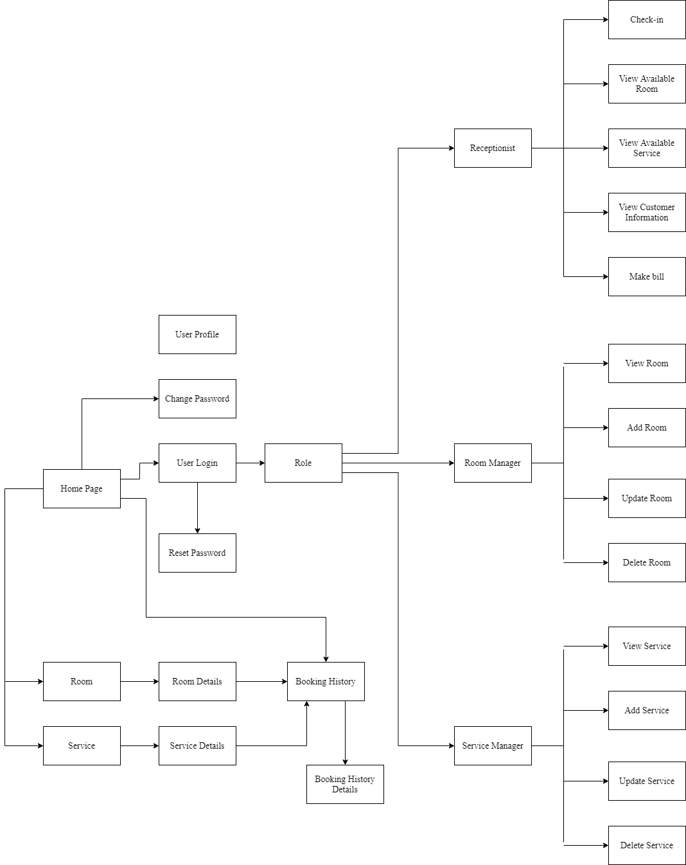

### 1.2 Screen Descriptions

| **#** | **Feature** | **Screen** | **Description** |
| --- | --- | --- | --- |
| 1 | Sign In | Login | Login to system |
| 2 | Forgot Password | Login | Change password if forgotten |
| 3 | Reset Password | Reset Password | When user forgot password, send a verification code through Email for user to reset password |
| 4 | Change Password | Change Password | Change User’s old password with new password |
| 5 | User Profile | User Profile | User views information about their account |
| 6 | View Room Available | Room, Manage Booking | Display detail information of Room |
| 7 | View Service Available | Service, Manage Booking | Display detail information of Service |
| 8 | Booking History | Booking | Display detail information of Booking |
| 9 | Check in | Manage Booking | Receptionist check-in for Customer |
| 10 | View Customer Information | Manage Booking | Receptionist can view the information of Customer |
| 11 | Make bill | Manage Booking | Receptionist calculate the payment when Customer check-out based on the information of booking room and service |
| 12 | View Room | Manage Room | Manager can view all of the rooms in the hotel |
| 13 | Add Room | Manage Room | Manager can add new room |
| 14 | Update Room | Manage Room | Manager can update the information of room and the status of rooms (available or not) |
| 15 | Delete Room | Manage Room | Manager can delete the room |
| 16 | View Service | Manage Service | Manager can view all of the services in the hotel |
| 17 | Add Service | Manage Service | Manager can add new service |
| 18 | Update Room | Manage Service | Manager can update the information of service and the status of services (available or not) |
| 19 | Delete Room | Manage Service | Manager can delete the service |

### 

### 

### 1.3 Screen Authorization

| **Screen** | **Receptionist** | **Room Manager** | **Service Manager** | **Manager** |
| --- | --- | --- | --- | --- |
| Dashboard | x | x | x | x |
| User Login | x | x | x | x |
| CRUD Room |  | x |  | x |
| CRUD Service |  |  | x | x |
| CRUD Staff |  |  |  | x |
| View Customer Information | x |  |  | x |
| Check-in | x |  |  |  |
| Check-out | x |  |  |  |
| Payment | x |  |  | x |
| User Profile | x | x | x | x |

### 

### 1.4 Non-Screen Functions

| **#** | **Feature** | **System Function** | **Description** |
| --- | --- | --- | --- |
| 1 | Remember Me | Login | System store user’s login account and password in cookies for future re-login. |
| 2 | API | Payment | The system displays customer payment information. |

### 1.5 Entity Relationship Diagram

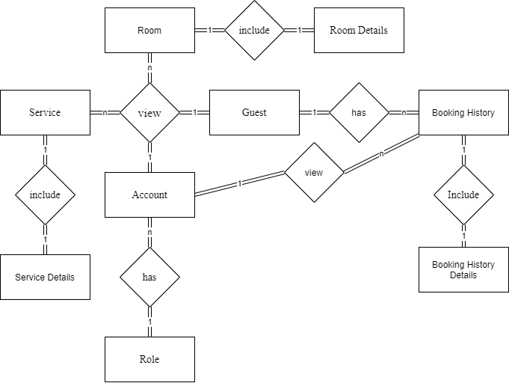

**Entities Description**

| **#** | **Entity** | **Description** |
| --- | --- | --- |
| 1 | Account | Each user will have 1 login account |
| 2 | Role | After logging in, the user's account will be redirected to the role they are assigned (receptionist, manager, ...) |
| 3 | Room | The list of room in the hotel |
| 4 | Room Details | The information of the room |
| 5 | Service | The list of service in the hotel |
| 6 | Service Details | The information of the service |
| 7 | Guest | Who can see the list of rooms and services on the hotel's homepage |
| 8 | Information | Customer information when booking a room |
| 9 | Booking History | Customer's previous booking history |
| 10 | Booking History Details | The information of booking history |

## 2. Screen Description

### 2.1. Dashboard

* Function description: Display overview of the number of rooms/services booked, number of rooms/services available, monthly revenue.
* Screen layout:

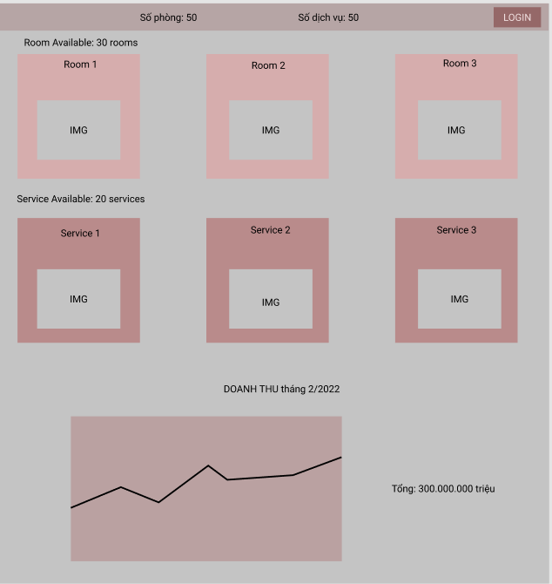

### 

### 2.2. User Login

* Function Trigger: After access to the homepage, clicking on a button for Login in the upper right corner (appears when not log in) will redirect the user to the Login page.
* Function description: Users that have not yet registered cannot log in. They must first register by clicking on the register command button. They should be able to do this without getting an error for an empty name or password field.
* Screen layout:

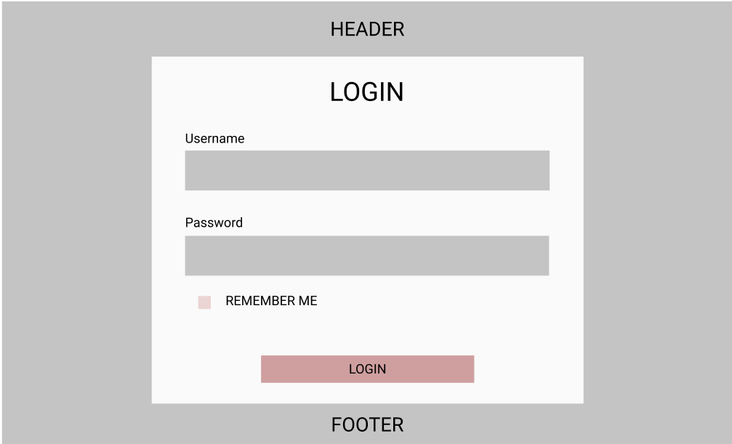

| # | Field name | Type | Max length | Description |
| --- | --- | --- | --- | --- |
| 1 | username | text box | 30 | include text, number |
| 2 | password | text box | 20 | include text, number, special characters |

* Function details:
* With username and password that user entered, the system will check in database that if username exist or account is enabled:
* Case 1: if username and password didn’t fit an account already registered -> the system will notice the user for the wrong username or for registering.
* Case 2: if username and password fit an account already registered -> checking for the password of this username in the database, and forwarding to the homepage with user information and token if the password is correct or notice for wrong password.
* Case 3: if system error -> the system will notice the user error page.
* Use cookies to save the user's information.

### 2.3. CRUD Room

#### Room List

* Function trigger: Manager clicks on “Room List” button.
* Function description: View room list.
* Screen layout:

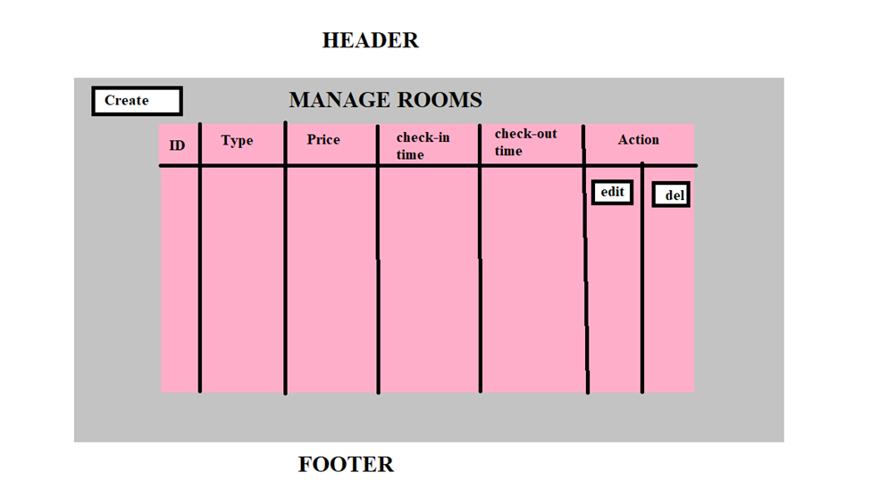

* Function details: When the manager logs in, they will see a list of the hotel's rooms.

#### Room Details

* Function trigger: Manager click on each room
* Function description: View room details.
* Screen layout:

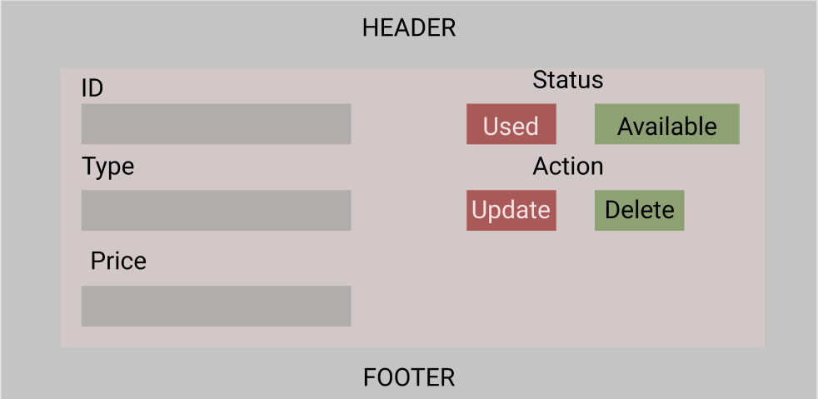

* Function details: When the manager logs in and clicks on each room, they will see the information of the room.

### 2.4. CRUD Service

#### Service List

* Function trigger: Manager clicks on “Service List” button.
* Function description: View service list.
* Screen layout:

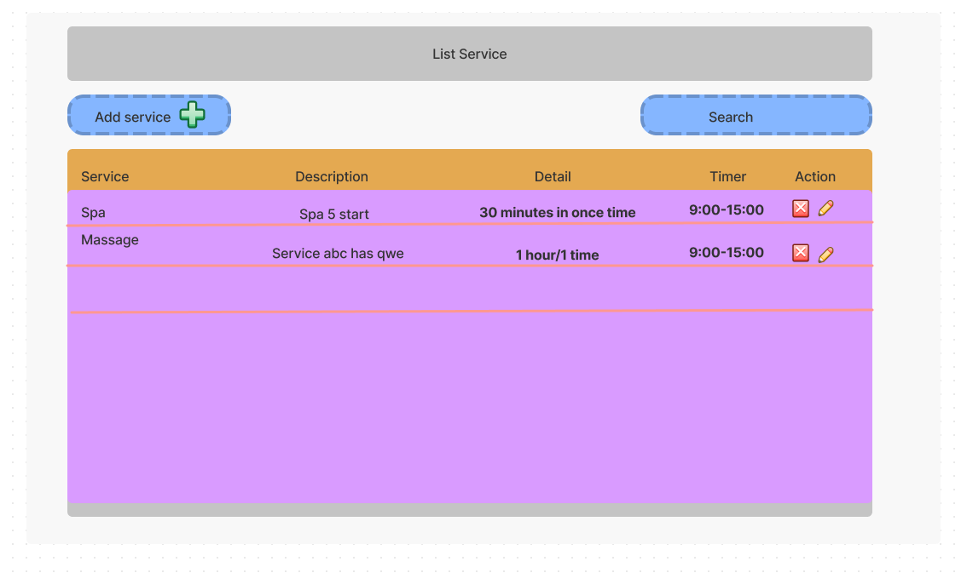

* Function details: When the manager logs in, they will see a list of the hotel's service.

#### Service Details

* Function trigger: Manager clicks on each service.
* Function description: View service details.
* Screen layout:

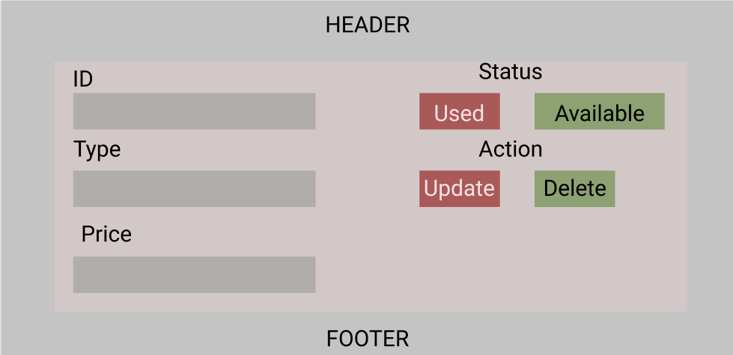

* Function details: When the manager logs in and clicks on each service, they will see the information of the service.

### 2.5. CRUD Staff

#### Staff List

* Function trigger: Manager clicks on “Staff List” button.
* Function description: View staff list.
* Screen layout:

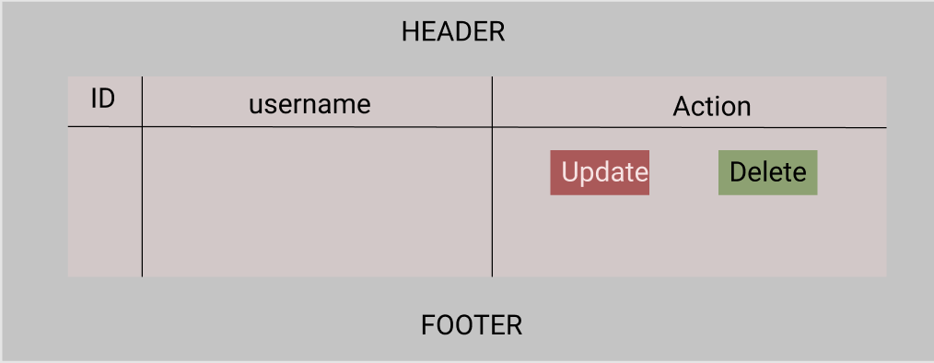

* Function details: When the manager logs in, they will see a list of the hotel's staff.

#### Staff Details

* Function trigger: Manager clicks on each staff member.
* Function description: View staff details.
* Screen layout:

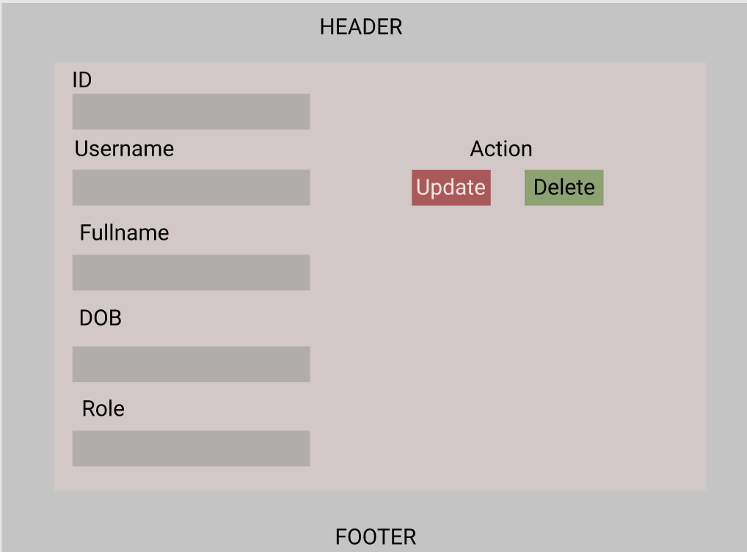

* Function details: When the manager logs in and clicks on each staff, they will see the information of the staff.

### 2.6. View Information of Customer

#### Customer List

* Function trigger: Receptionist clicks on “Customer List” button.
* Function description: View Customer list.
* Screen layout:

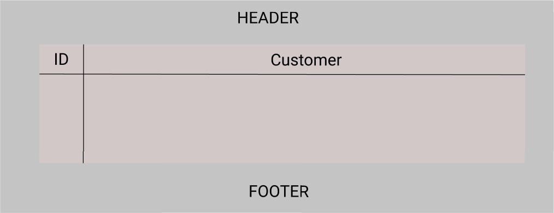

* Function details: When the receptionist logs in, they will see a list of the hotel's Customer.

#### Customer Details

* Function trigger: Receptionist/Manager clicks on each Customer member.
* Function description: View customer details and the number of times they book the room or use the service.
* Screen layout:

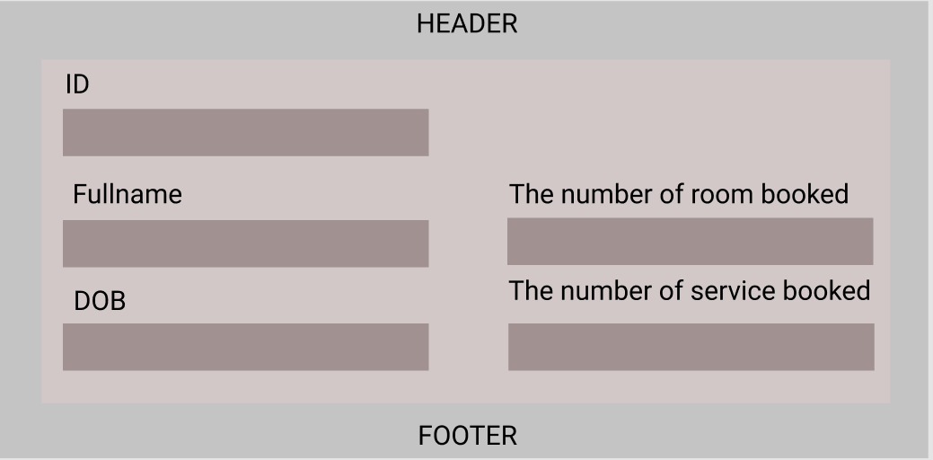

* Function details: When the manager logs in and clicks on each customer, they will see the information of the customer.

### 2.7. Check-in information Customer

* Function trigger: Receptionist click on “Check-in” from Dashboard.
* Function description: View list of all Customers and search the Customer. Receptionists also add new customers when they check-in.
* Screen Layout:

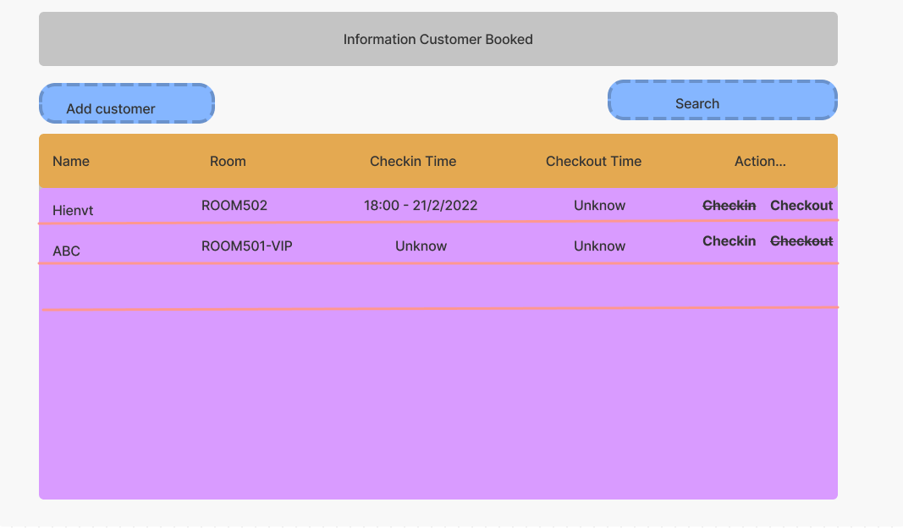

* Function details: When receptionists log in, they can see the check-in screen.

### 2.8. Check-out information

* Function trigger: When the receptionist clicks on the “Check-out” button.
* Function description: View receipt.
* Screen layout:

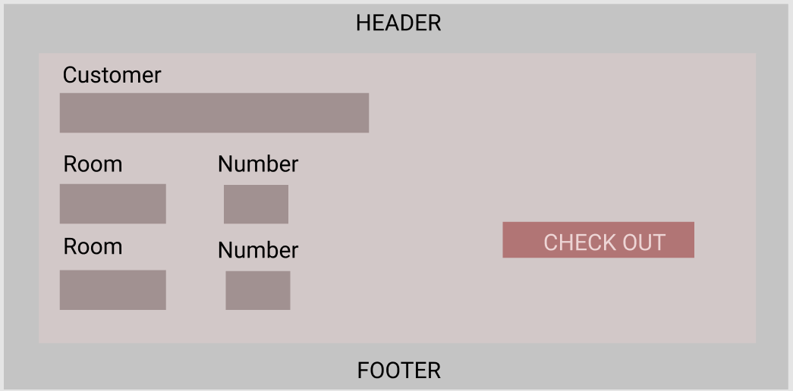

* Function details: When Customer wants to check-out, the receptionist will see the information of booking of customer.

### 2.9. Payment

* Function trigger: When the receptionist clicks on the “Check-out” button.
* Function description: View receipt.
* Screen layout:

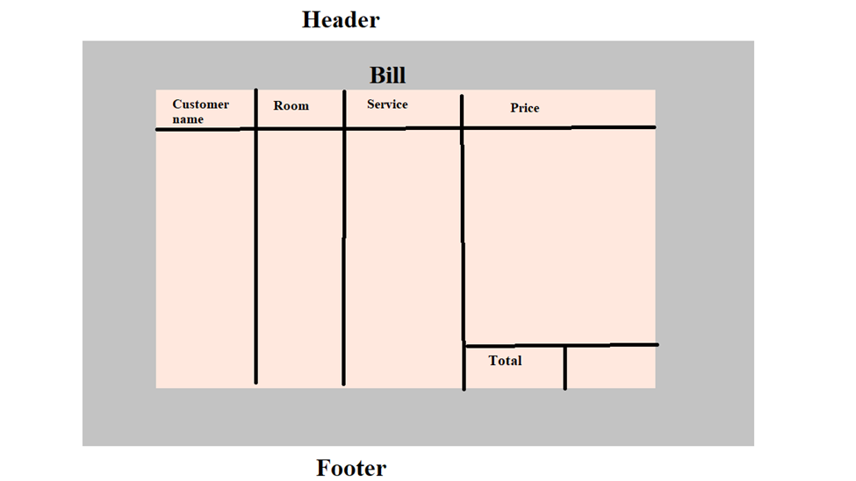

* Function details: Receptionist calculate the payment when Customer check-out based on the information of booking room and service.

### 2.10. User Profile

* Function trigger: User log-in the website and click on the profile icon on the top-right corner.
* Function description: Users can see their account’s detailed information.
* Screen layout:

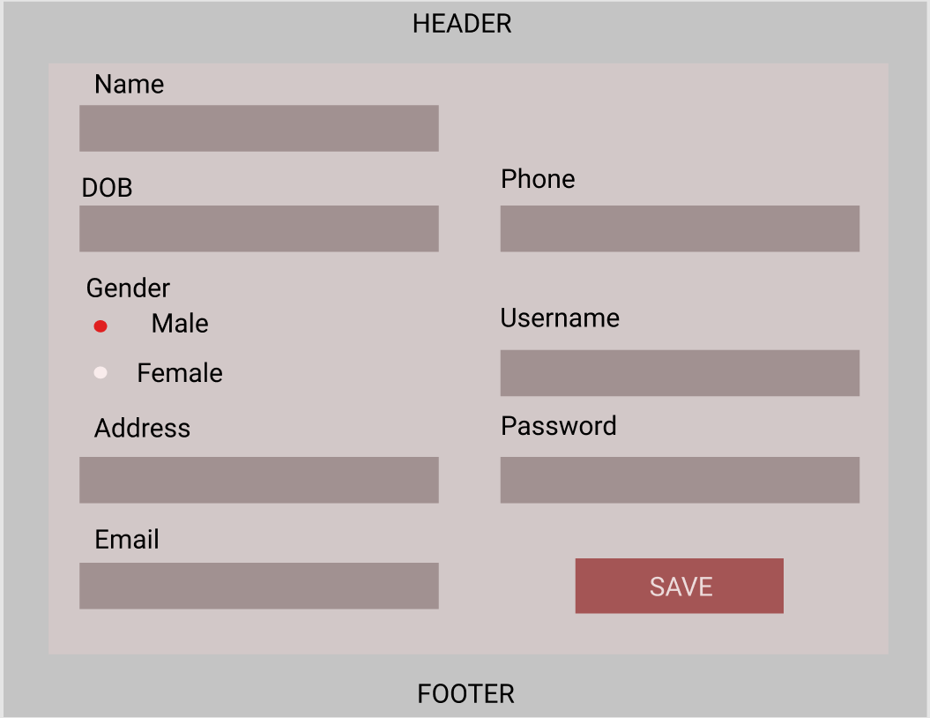

* Function details: Allow user view and update information/password.

# 

# IV. Non-Functional Requirements

## 1. External Interfaces

### 1.1. Software Interfaces

#### SI-1. Hotel Inventory System

The HMS will communicate with the Hotel Inventory System through a programming interface for the following operations:

SI-1.1. The HMS will transmit the number of people and the number of check-ins.

SI-1.2. HMS will poll the HIS to determine available rooms.

SI-1.3. The HIS notifies the HMS that a particular room is no longer available.

SI-1.4. The HMS will poll the HIS to determine if guests are available to request an available menu.

SI-1.5. The HIS informs HMS that the item will be removed from the current day's menu.

### 1.2. Communications Interfaces

CI-1. The HMS shall send an email or text message (based on user account settings) to the Customer to confirm Booking acceptance, price, and check-in time.

CI-2: The HMS shall send an email or text message (based on user account settings) to the Customer to report any problems with order room or food order

## 

## 2. Quality Attributes

### 2.1. Usability

USE-1: The HMS shall allow customers to retrieve their previous reservation and food order in just 45 seconds. After 45 seconds, the hotel staff has confirmed that if you want to cancel the reservation, you must contact the hotel staff.

USE-2: 95% of new users shall be able to successfully check-in and check out without errors on their first try.

### 2.2. Safety

### SAF-1: The user will be able to see a list of all hotel rooms and hotel menu. Regarding hotel rooms, customers can see reviews of quality, room rates and promotions that customers receive when booking by type. On the hotel menu, customers can see the price of the dish, the ingredients of the dish.

### 

### 2.3. Availability

AVL-1: Data update time before working time 8:00 am and after 8:00 pm.

### 2.4. Security

SEC-1: All network transactions that involve financial information or personally identifiable information shall be encrypted.

SEC-2: Users must log in to the HMS for all operations.

SEC-3: Only hotel employees are authorised to manipulate, edit and manage all customer information, and manipulate food and menu orders.

SEC-4: The system will allow users to review past and current booking information.

### 2.5. Performance

PER-1: The system shall accommodate a total of 1 user and a maximum of 10 concurrent users during working-time.

PER-2: 100% data will be saved safely.

PER-3: The system shall display confirmation messages to users within an average of 1 seconds and a maximum of 2 seconds after the user submits information to the system.

PER-4: The system shall display data to users within an average of 1 seconds and a maximum of 3 seconds after the user requests to see information to the system.